SSE Assignment 04

Which structures of a Petri net are typically used to model the following elements? Draw one small example for each of them.

1. Concurrent processes (parallel, independent sequences of events)

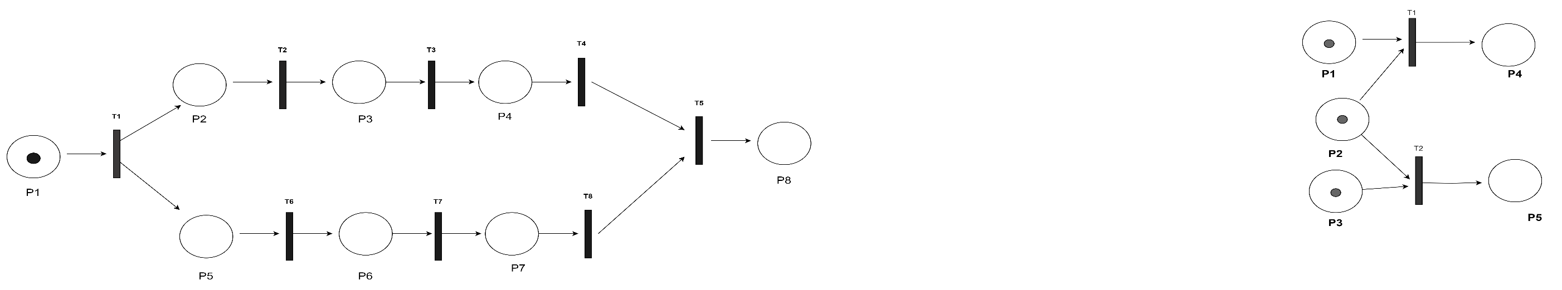

1. Conflicts (activity sets out of which only one can happen in a certain state)

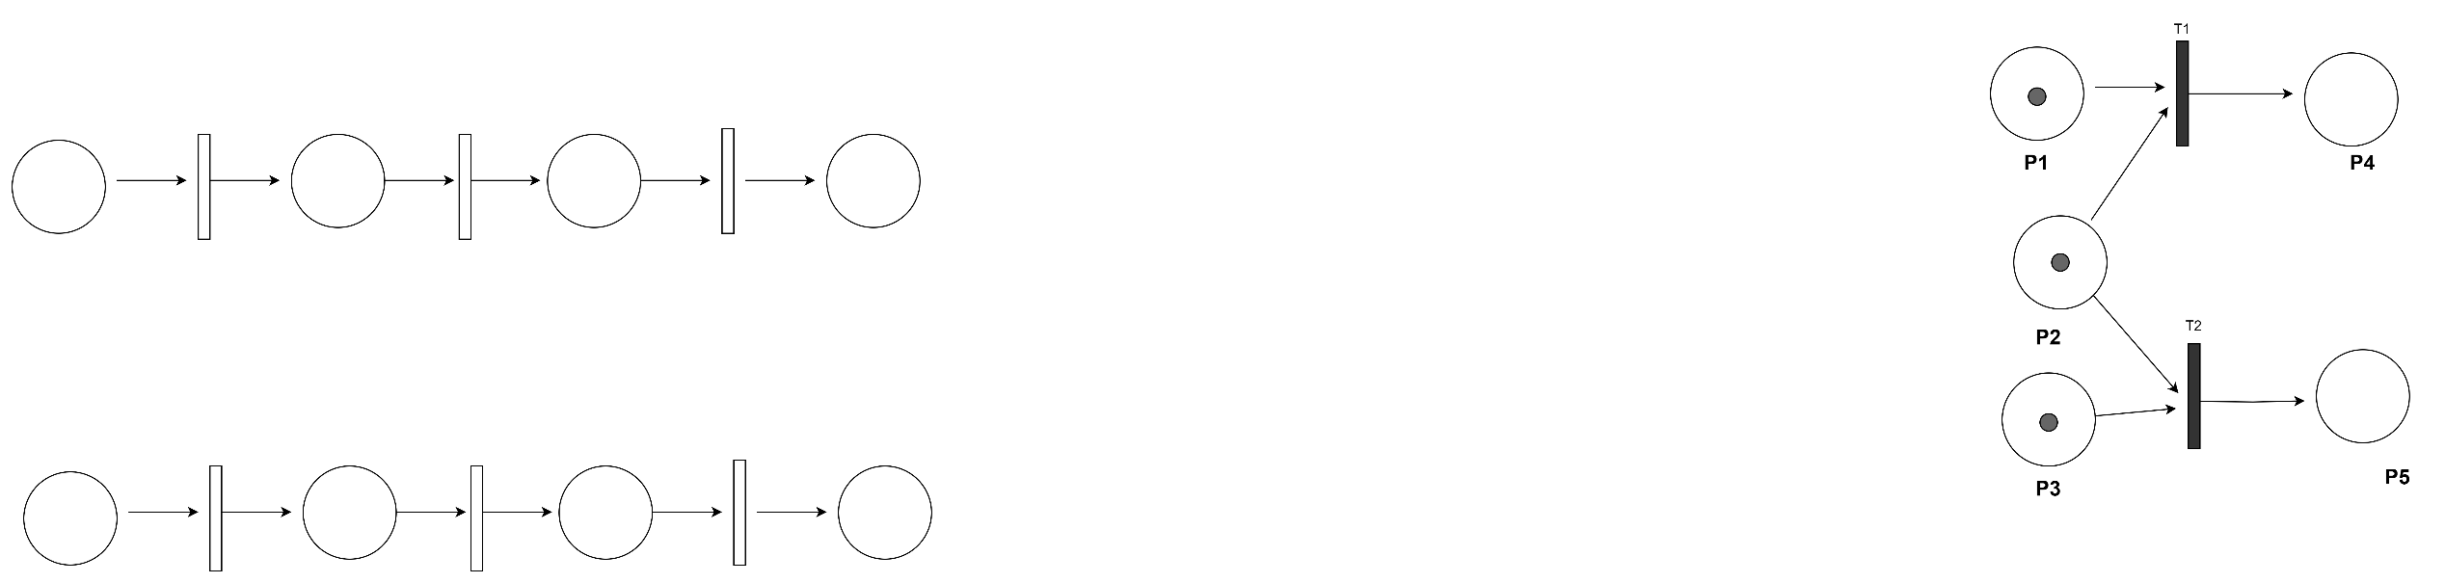

1. Sequences of events (activities that simply follow each other)

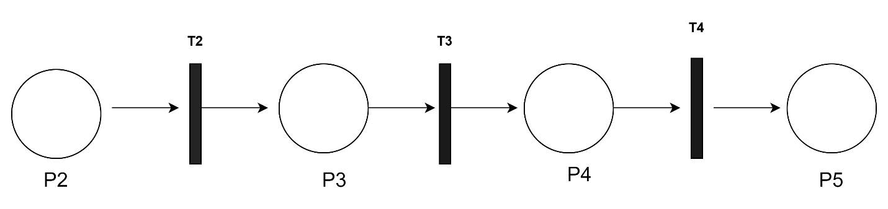

1. Testing state conditions (i.e., an activity should only happen under a certain value setting of state variables)

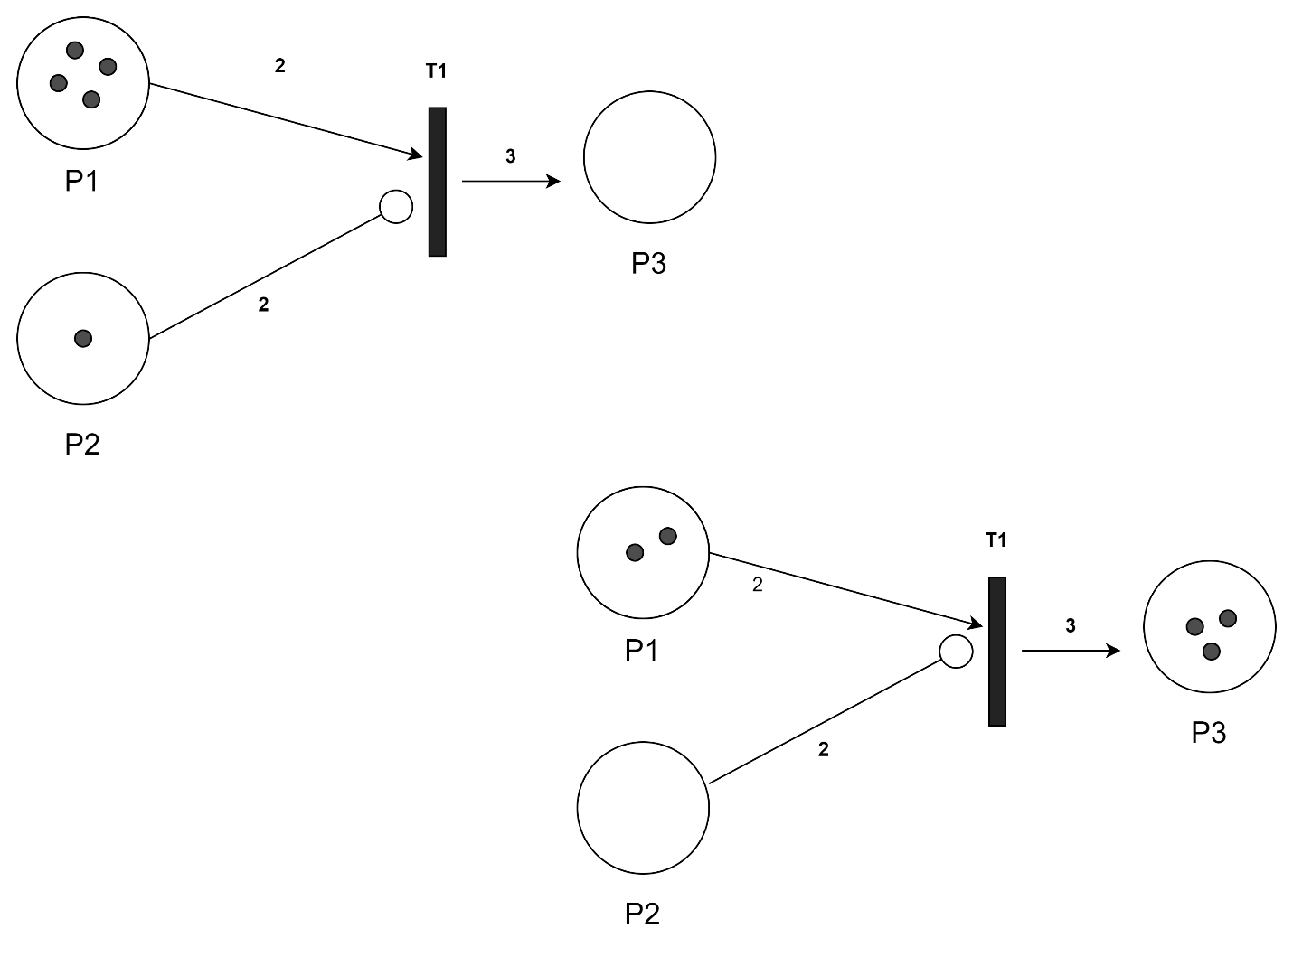

e) Mutual exclusion (i.e., two processes should never be in the same state together, also used in critical sections or transactional access)

